The Flower-School by Rabindranath Tagore

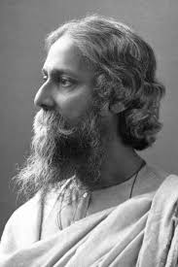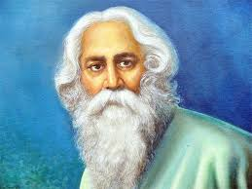

Rabindranath Tagore, Bengali Rabīndranāth Ṭhākur, (born May 7, 1861, Calcutta [now Kolkata], India—died August 7, 1941, Calcutta), Bengali poet, short-story writer, song composer, playwright, essayist, and painter who introduced new prose and verse forms and the use of colloquial language into Bengali literature, thereby freeing it from traditional models based on classical Sanskrit. He was highly influential in introducing Indian culture to the West and vice versa, and he is generally regarded as the outstanding creative artist of early 20th-century India. In 1913 he became the first non-European to receive the Nobel Prize for Literature.

The Flower-School by Rabindranath Tagore is a beautiful poem depicting his longing for his deceased mother.
The poet starts the poem by portraying a rainy day scene from the cloudy sky and shower coming down in the month of June. The wind passing through bamboo bower produces a melodious sound.
In the rainy season, the flowers blossom out of nowhere and dance joyously; here the poet communes with his mother saying he feels the flowers go to school underground where they learn their lessons behind the shut doors; their master doesn’t let them come out to play.
However, when the rains fall, they have their holidays. In the rains the branches of trees in the forest clash, the loud clouds make noise by clapping their big hands; at this time the flower children come out dressed in vibrant colors.
In the last stanza, the poet’s longing for his deceased mother evokes pathos in the reader’s mind. He asks his mother if she knew the flowers’ home too was in the sky among the stars. He again asks her if she had not noticed how eager the flowers always were to get back to their home.
The last line of the poem brings tears to the eyes of the readers. The poet says he knows why the flowers raise their arms to the sky. They do so because their mother is in the sky, exactly like the poet’s mother who also became a star in the sky after her demise.
This poem is a vivid description of budding flowers and their growth in Spring, and it compares flowers to young school children. The speaker seems to be a young child, who speaks to a mother figure in the poem saying that he believes that the flowers must go to school underground. The flowers bursting from the ground and reaching to the sky for their mother remind the poet of vibrant school children who have been kept indoors for too long.

